Lab 2: Inverter Characteristics and the Ring Oscillator

Joseph Martinsen

ECEN 248 – 510

TA: Michael Bass

Date: September 19, 2016

**Objectives:**

This lab had two separate parts that both hoped to introduce the student into the ins and outs of a hex inverter. The lab hopes to also allow the student to become aware of the difference of having a circuit with an odd number of inverters compared to an even number. Since the inverters we are using are not perfect, we will also see that there is a “no-mans” zone in between high voltage and low voltage output from the inverter. Finally, when having multiple inverters connected in a loop, students will become aware of time delays that result from this.

**Design:**

Part 1

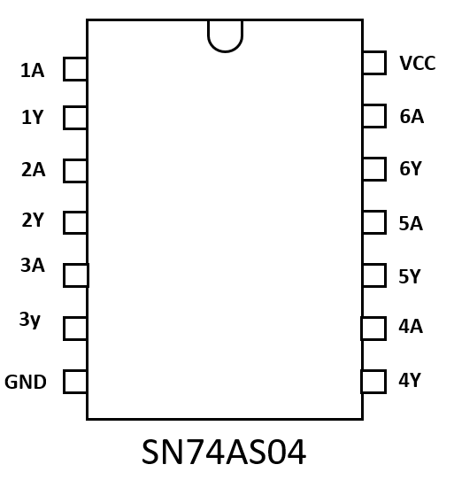

*Figure 1*

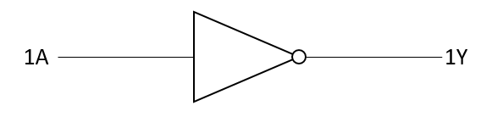

*Figure 2*

The first part utilized one breadboard, one SN74LS04N hex inverter (f*igure 2*), one voltmeter, and cables. The inverter was placed in the center of the breadboard in a manner such that either sides of the inverter are not closing the circuit prematurely. The power supply was then turned on with the twenty-volt output being set to output five volts. The cable coming out of the twenty-volt source of the power supply was connected to VCC (*figure 1*). The grounding cable was connected in series to the GND of the breadboard. Now the cable coming from the five volt output was connected in series with 1A (*figure 1)* of the inverter. A final cable was connected in series with 1Y of the inverter (*figure 1).* Now the cable from COM on the voltmeter was connected to ground ‘-‘ and the volt reading cable was connected to the 1Y cable. Now it is time to start taking readings.

The power supply connected to 1A was then set to output zero volts. The output of 1Y was recorded. The same power supply was then set to output two-tenths of a volt. This increments of two-tenths of volt was continued until reaching five volts. Data is recorded in *Table 1.*

Part 2

For the second part of this lab, the main circuitry starts off the same except the power source connected to 1A is disconnected. Other cables are also added such that 1Y is connected to 2A, 2Y is connected to 3A, 3Y is connected to 4A, 4Y is connected to 5A, and finally 5Y is connected to 1A. The power connected to VDD is set to five volts and the oscilloscope is connected to ground and to the cable connecting 3Y to 4A (any connection between inverters could have been used). By reading the oscilloscope the $Δt$ and frequency is recorded.

**Results:**

Part 1

|  |  |
| --- | --- |
| **Input Voltage** | **Output Voltage** |
| 0 V | 3.996 V |
| .2 V | 3.990 V |
| .4 V | 3.990 V |
| .8 V | 3.750 V |
| 1. V | 3.431 V |
| 1.2 V | 3.142 V |
| 1.3 V | 2.622 V |
| 1.4 V | 1.39 V |
| 1.5 V | 57.5 mV |
| 1.6 V | 56.8 mV |
| 1.8 V | 56.8 mV |
| 2. V | 56.8 mV |
| 2.5 V | 56.8 mV |
| 3. V | 56.8 mV |
| 3.5 V | 56.8 mV |
| 4. V | 56.8 mV |
| 5. V | 56.8 mV |
| *Figure 1* | |

Above is a table of the recorded inputs compared to the output of the inverter. The data was then plotted with INPUT VOLTAGE as the x-axis and OUTPUT VOLTAGE as the y-axis.

Part 2

The following was recorded by the oscilloscope:

$$Δt=71 ns \\ f=14.08 mHz$$

**Conclusion:**

In this lab, it became apparent how much of a difference just adding one inverter will do to a circuit. If there are an even number of inverters, the voltage input will be constant for every inverter. If there are an odd number of inverters, the voltage input will oscillate thus causing there to be a frequency in voltage.

For the first part, using a SN74LS04N inverter used with a VCC of five volts results in having have “no-mans” zone between 1.0 volts and 1.8 volts.

**Questions:**

1. **Plot the voltage transfer characteristics with Vin on x-axis and Vout on y-axis. Mark the range of voltages in output and input as Logic 0 and Logic 1. Determine the range of input voltage for which the inverter shows Logic 1 as output. Also determine the range of input voltage for which the inverter shows Logic 0 as output**

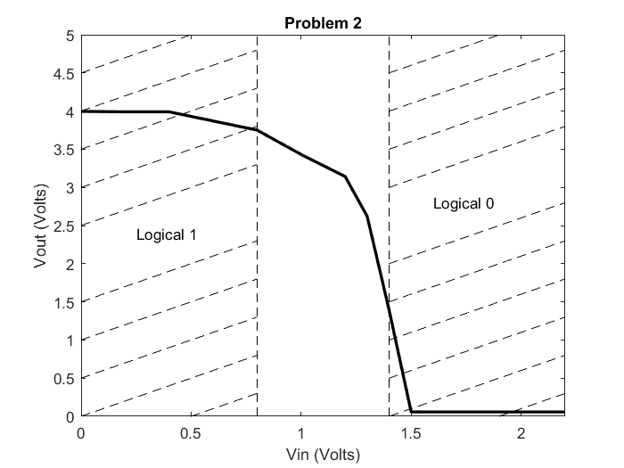

The range of voltage of input that results in an output of logical 1 is [0,0.8] volts. The range of voltage of input and input that results in an output of logic 0 is [1.4,5].

1. **Derive the single-stage delay of the Ring Oscillator from the time period of oscillation that you see in Experiment 2. If the delay of one inverter is 10ns, what will be the frequency of the signal generated from a 21 stage ring oscillator?**

The single-stage delay for the Ring Oscillator used in my lab was $\frac{71ns}{5 inverters}=14.2 ns$

For a 21 stage ring oscillator, the frequency is:

$$T=21*10*2$$

$$f=\frac{1}{T}=\frac{1}{420ns}=24mhz$$

1. **Are the signals at P, Q, R, S in Figure 2 periodic? If so, what are their time periods? How do these signals differ from the signal at node A?**

The signals in the inverters in figure 2 will be periodic because there are an odd number of inverters. The frequency of the signals at P, Q, R, and S will be lower compared to the signal at node A.